Water’s Cycle BBC Worldwide Limited 2003
Name___________________________________________________ Period _________NB#__________

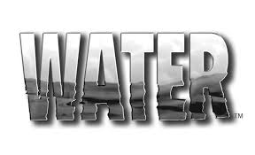
- Why is water considered one of the most important substances on Earth?

- Why does peat hold so much water?

- What is ground water?

- What does it mean when the water table is close to the Earth’s Surface?

- What is created when a dam is built? What is its purpose?

- What processes must water go through before it is ready to drink?

- What is the importance of wastewater treatment plants?

- What is the difference between evaporation and condensation?

- What is Lake Mead’s main source of water?

- Name some of the communities that rely on Lake Mead for water.

